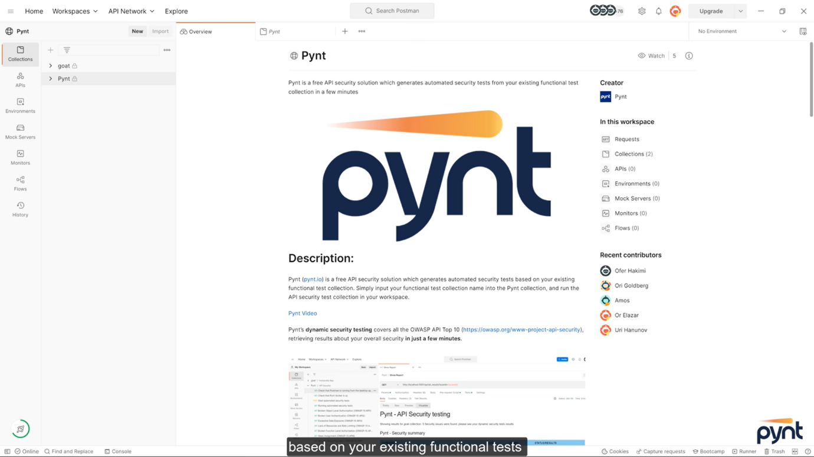
API SECURITY TESTING
Figure 1.1: Pynt (postman) tool has been used for API testing to test goat collection

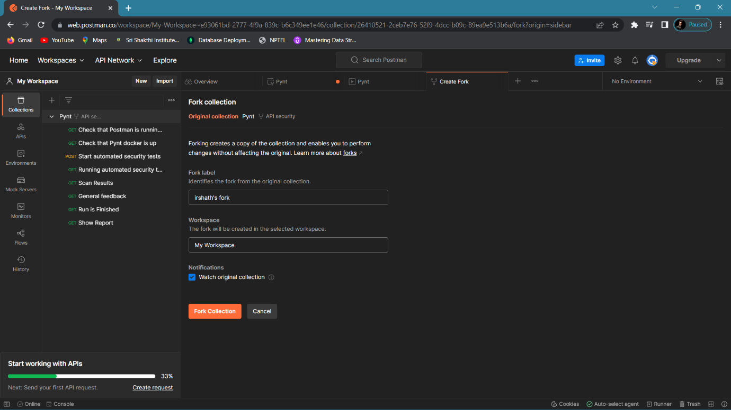
Figure 1.2: Create a fork

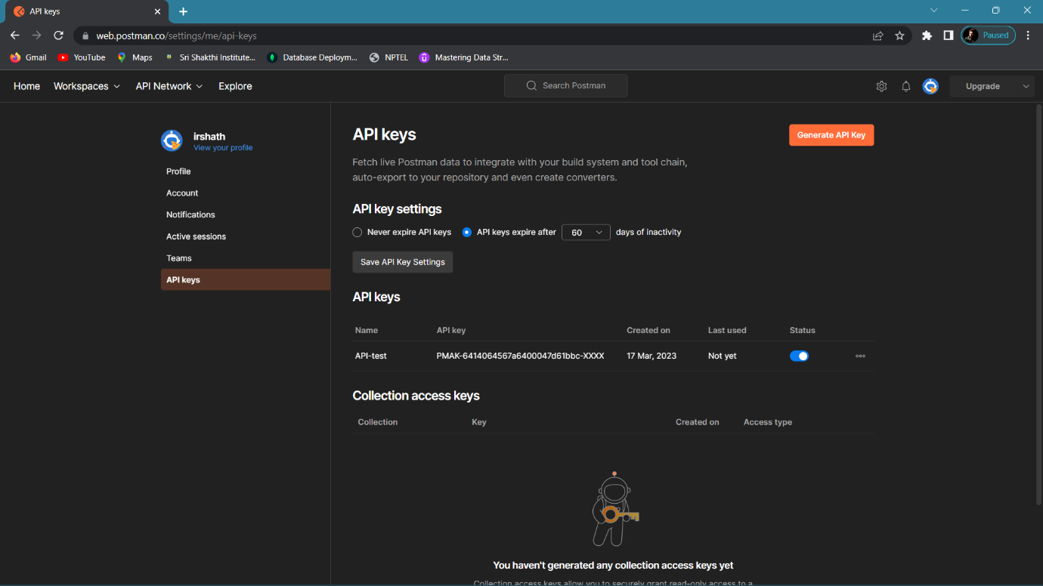
Figure 1.3: Generate API key
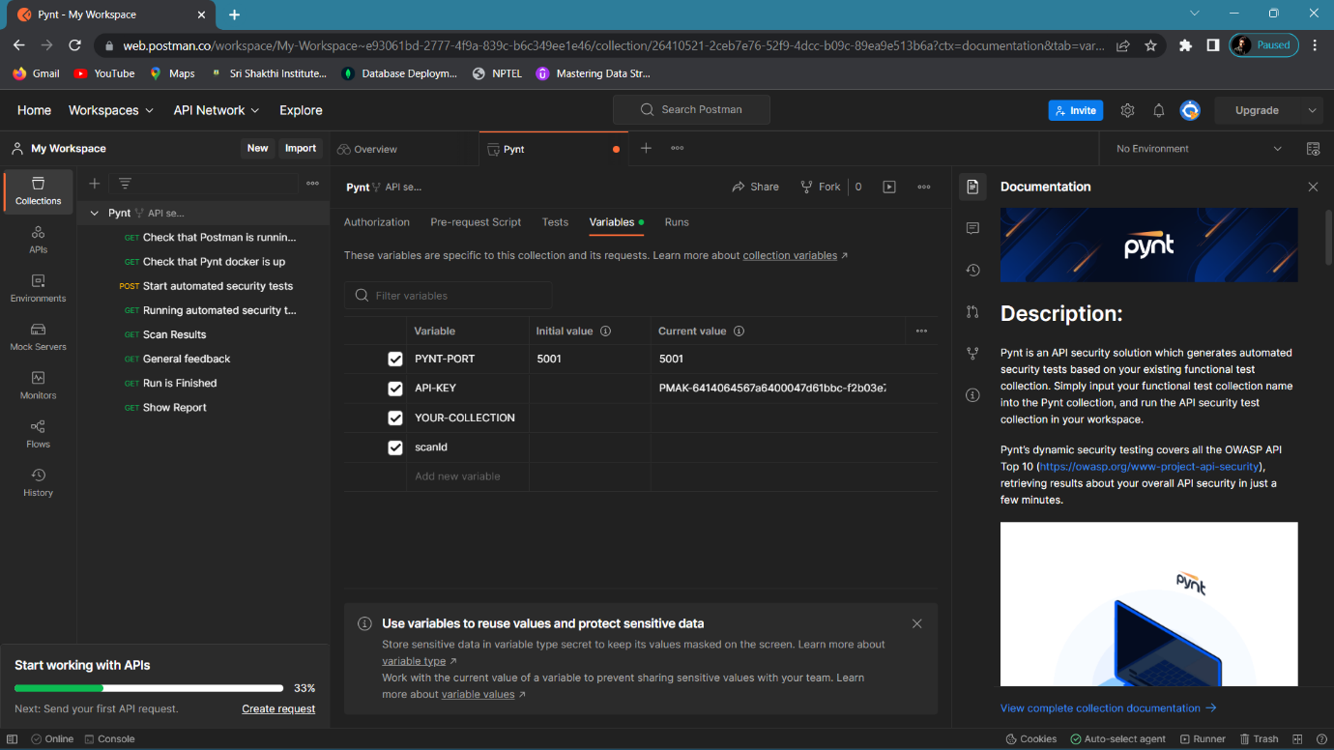
Figure 1.4: Insert a generated API key to the variable
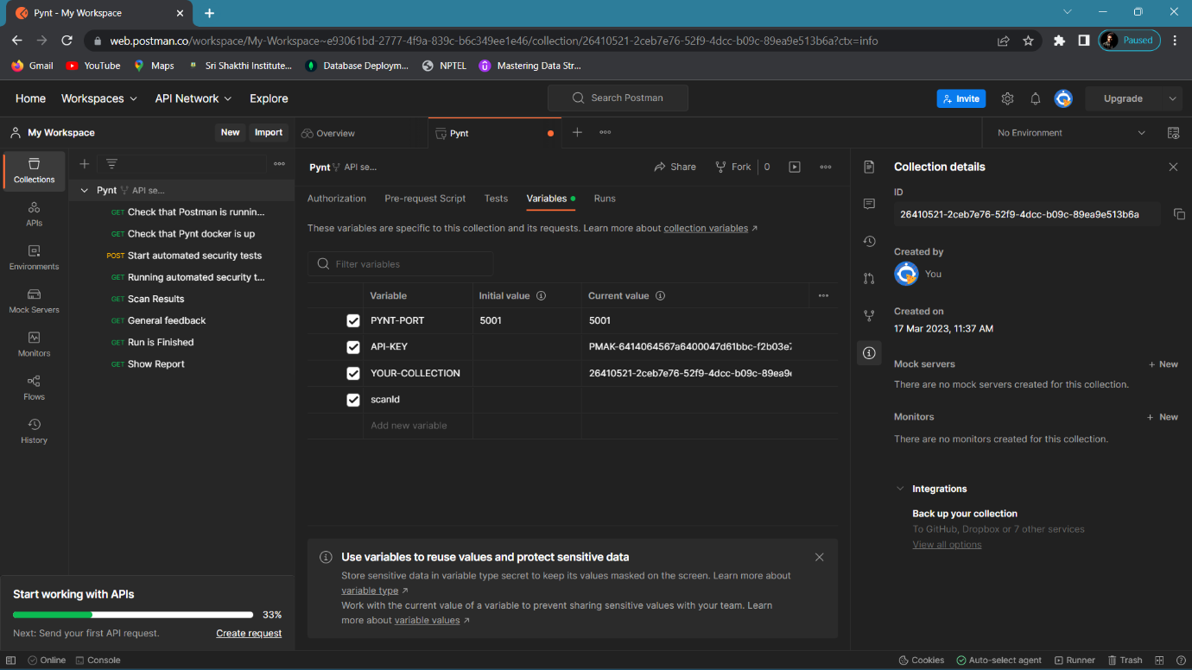
Figure 1.5: Inserted a collection detail

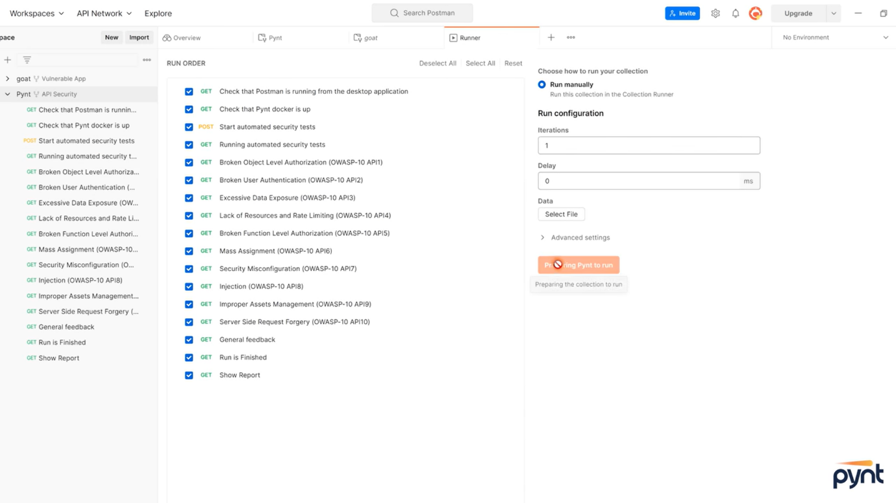
Figure 1.6: Run the PYNT collection.
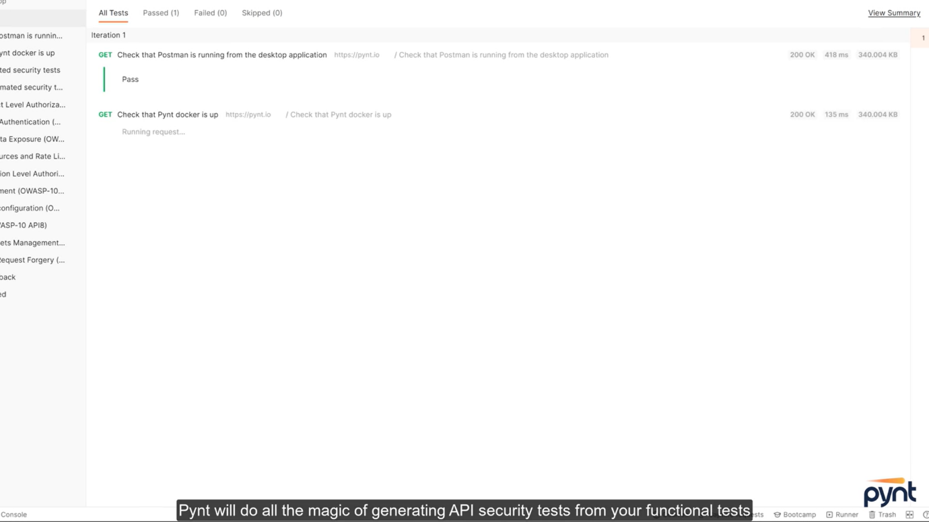
Figure 1.7.1: Collection running
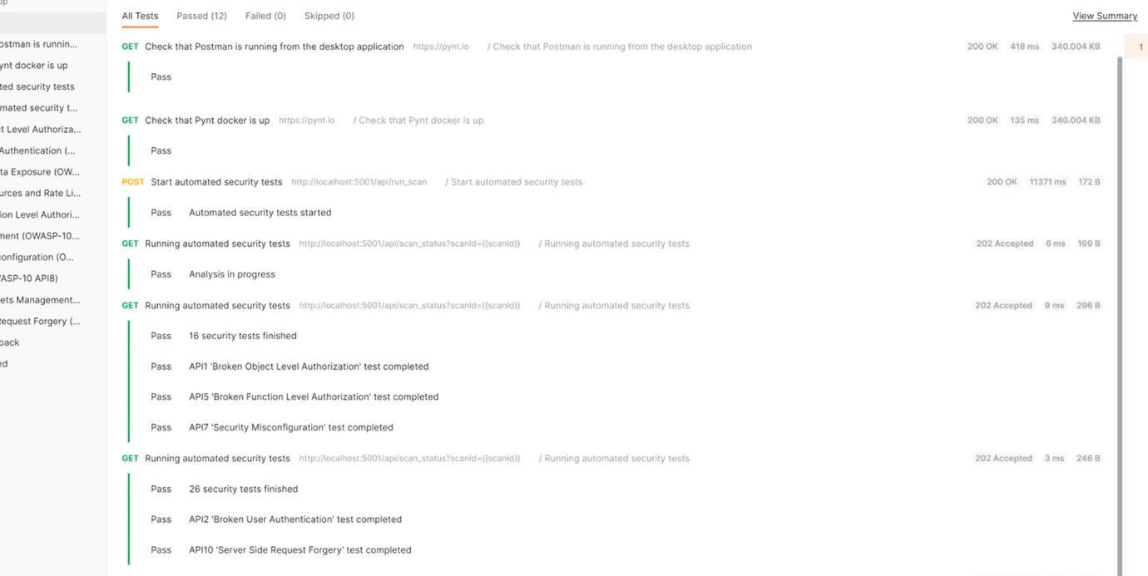
Figure 1.7.2: Collection running

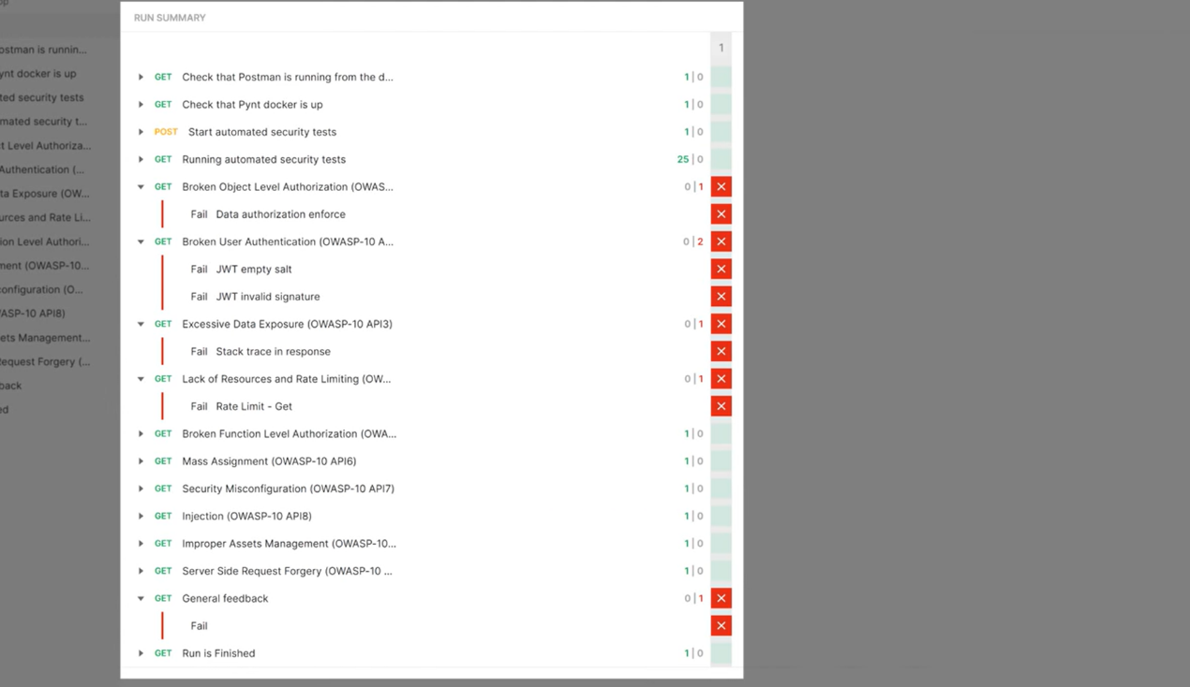
Figure 1.8: Result

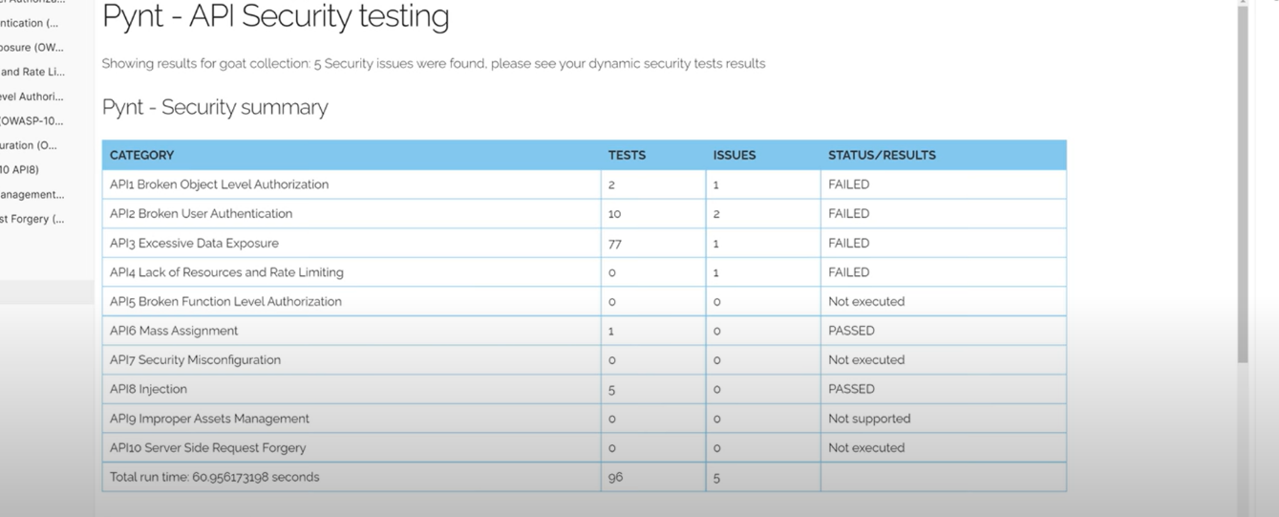
Figure 1.9: Summary of the collection

Issues in collections:-
- Broken Object Level Authentication
- Broken User Authentication
- Excessive Data Exposure
- Lack of Resources and Rate Limiting
How to Solve this errors:-
Broken Object Level Authorization:-
- Broken object level authorization occurs when a web application fails to properly enforce access controls on resources or objects, allowing unauthorized users to access or modify sensitive data. To solve this issue, you can follow these steps:

- Identify the vulnerability: First, you need to identify the specific vulnerabilities that are causing the broken object level authorization. This can be done through security testing and vulnerability scanning tools.

- Implement proper access controls: Once you have identified the vulnerabilities, you should implement proper access controls for each resource or object in the web application. This can be done by using role-based access control (RBAC), attribute-based access control (ABAC), or other access control mechanisms.

- Use secure coding practices: You should also ensure that your web application is developed using secure coding practices. This can include using input validation and output encoding, using parameterized queries, and avoiding the use of insecure functions.

- Regularly test and monitor: You should regularly test and monitor your web application for vulnerabilities and suspicious activity. This can include performing penetration testing, vulnerability scanning, and monitoring user activity logs.

- Stay up-to-date with security best practices: Finally, it's important to stay up-to-date with the latest security best practices and industry standards. This can include following OWASP guidelines, attending security conferences and training, and keeping your software and tools updated with the latest security patches.

Broken User Authentication:-

- Broken user authentication is a security vulnerability that occurs when an application allows attackers to bypass authentication controls and gain access to sensitive data or functionality. Here are some steps you can take to solve this issue:

- Implement strong authentication controls: Use strong authentication controls, such as multi-factor authentication, to prevent unauthorized access. Make sure passwords are stored securely, and consider using password hashing algorithms and encryption.

- Use secure session management: Implement secure session management by using secure cookies and ensuring that sessions are invalidated when a user logs out or after a certain amount of idle time.

- Validate all user input: Validate all user input to prevent attacks such as SQL injection and cross-site scripting (XSS). Use parameterized queries and input validation to avoid injection attacks.

- Limit access based on roles: Limit access to sensitive data and functionality based on user roles. This ensures that users only have access to what they need to perform their job functions.

- Monitor and log user activity: Monitor and log user activity to detect suspicious activity and unauthorized access attempts. Use tools such as intrusion detection systems (IDS) and Security Information and Event Management (SIEM) to identify potential attacks.

- Stay up-to-date with security best practices: Stay up-to-date with the latest security best practices and industry standards. Follow OWASP guidelines, attend security conferences and training, and keep your software and tools updated with the latest security patches. Regularly perform security assessments and penetration testing to identify and remediate vulnerabilities.

Excessive Data Exposure:-
- Excessive data exposure is a security vulnerability that occurs when an application exposes too much sensitive data, such as passwords or personal information, to unauthorized users. Here are some steps you can take to solve this issue:

- Implement data encryption: Implement data encryption to protect sensitive data in transit and at rest. Use strong encryption algorithms, such as AES, and keep encryption keys secure.

- Implement access controls: Implement access controls to limit access to sensitive data to authorized users only. Use role-based access controls (RBAC) or attribute-based access controls (ABAC) to ensure that only users with the appropriate permissions can access the data.

- Minimize data collection: Minimize the amount of data collected by the application to reduce the risk of exposure. Only collect the data that is necessary for the application to function properly.

- Implement secure coding practices: Implement secure coding practices, such as input validation and output encoding, to prevent attacks such as SQL injection and cross-site scripting (XSS).

- Use secure communication protocols: Use secure communication protocols, such as HTTPS, to protect data in transit. Ensure that certificates are valid and up-to-date.

- Monitor and log user activity: Monitor and log user activity to detect suspicious activity and unauthorized access attempts. Use tools such as intrusion detection systems (IDS) and Security Information and Event Management (SIEM) to identify potential attacks.

- Stay up-to-date with security best practices: Stay up-to-date with the latest security best practices and industry standards. Follow OWASP guidelines, attend security conferences and training, and keep your software and tools updated with the latest security patches. Regularly perform security assessments and penetration testing to identify and remediate vulnerabilities.

Lack of Resources and Rate Limiting:-
- Lack of resources and rate limiting errors are security vulnerabilities that occur when an application does not have enough resources to handle the volume of traffic it receives or when it does not have appropriate rate limiting measures in place to prevent attacks such as denial of service (DoS). Here are some steps you can take to solve this issue:

- Scale your infrastructure: Increase the resources available to your application by scaling your infrastructure. This can include adding more servers or using cloud-based services to increase capacity.

- Implement rate limiting: Implement rate limiting to prevent attackers from overwhelming your application with requests. Use mechanisms such as IP-based rate limiting, token bucket algorithms, or distributed rate limiting to prevent DoS attacks.

- Use caching: Use caching to improve performance and reduce the load on your servers. This can include using in-memory caching, content delivery networks (CDNs), or browser caching.

- Optimize your code: Optimize your code to improve performance and reduce the amount of resources needed to handle requests. Use techniques such as code profiling and caching to identify and fix performance bottlenecks.

- Monitor and log traffic: Monitor and log traffic to detect suspicious activity and identify potential DoS attacks. Use tools such as intrusion detection systems (IDS) and Security Information and Event Management (SIEM) to identify potential attacks.

- Perform load testing: Perform load testing to identify the maximum capacity of your application and ensure that it can handle the expected volume of traffic.

- Stay up-to-date with security best practices: Stay up-to-date with the latest security best practices and industry standards. Follow OWASP guidelines, attend security conferences and training, and keep your software and tools updated with the latest security patches. Regularly perform security assessments and penetration testing to identify and remediate vulnerabilities.

